1
A
Summer Internship Report
On
"AI CUSTOM TRIP PLANNER"

(CE446 – Summer Internship - II)

Prepared by
Palak Bhut(24CE016)

Under the Supervision of
Mr. Parmanand Patel

Submitted to
Charotar University of Science & Technology (CHARUSAT)
for the Partial Fulfillment of the Requirements for the
Degree of Bachelor of Technology (B.Tech.)
for Semester 4

Submitted at





U & P U. PATEL DEPARTMENT OF COMPUTER ENGINEERING
Chandubhai S. Patel Institute of Technology (CSPIT)
Faculty of Technology & Engineering (FTE), CHARUSAT
At: Changa, Dist: Anand, Pin: 388421.
July 2026

DECLARATION BY THE CANDIDATE

I hereby declare that the project report entitled "AI Powered Custom Trip Planner Using WordPress and Google Gemini AI" submitted by me to Chandubhai S. Patel Institute of Technology (CSPIT), Changa, in partial fulfillment of the requirement for the award of the degree of Bachelor of Technology in Computer Engineering, from U & P U. Patel Department of Computer Engineering, is a record of my bonafide CE446 – Summer Internship – II carried out during the internship period under the guidance of my industry mentor and faculty guide.
I further declare that the work carried out and documented in this project report has not been submitted anywhere else, either in part or in full, for the award of any other degree or diploma in this institute or any other institute or university. The work presented in this report is original and has been carried out by me.

Palak Bhut
Enrollment No.: 24CE016

Industry Mentor
Mr./Ms. Sumit Patel
Company Name: happiness pro

Faculty Guide
Prof. Parmanand Patel
U & P U. Patel Department of Computer Engineering
CSPIT/FTE, CHARUSAT, Changa



CERTIFICATE

This is to certify that the report entitled “AI custom trip planner” is a bonafied work carried out by Palak Bhut(24CE016) under the guidance and supervision of Prof. Parmanand Patel/ Mr. Sumit Patel for the subject Summer Internship – II (CE446) of 7th Semester of Bachelor of Technology in Computer Engineering at Chandubhai S. Patel Institute of Technology (CSPIT), Faculty of Technology & Engineering (FTE) – CHARUSAT, Gujarat.

To the best of my knowledge and belief, this work embodies the work of candidate herself, has duly been completed, and fulfills the requirement of the ordinance relating to the B.Tech. Degree of the University and is up to the standard in respect of content, presentation and language for being referred by the examiner(s).

Under the supervision of,  Prof. Parmanand Patel  Counsellor  U & P U. Patel Dept. of Computer Engineering  CSPIT, FTE, CHARUSAT, Changa, Gujarat | Mr. Sumit Patel  Partner  Happiness pro
Dr. Nikita Bhatt
Head - U & P U. Patel Department of Computer Engineering,
CSPIT, FTE, CHARUSAT, Changa, Gujarat.

Chandubhai S. Patel Institute of Technology (CSPIT)
Faculty of Technology & Engineering (FTE), CHARUSAT
At: Changa, Ta. Petlad, Dist. Anand, Pin: 388421. Gujarat.

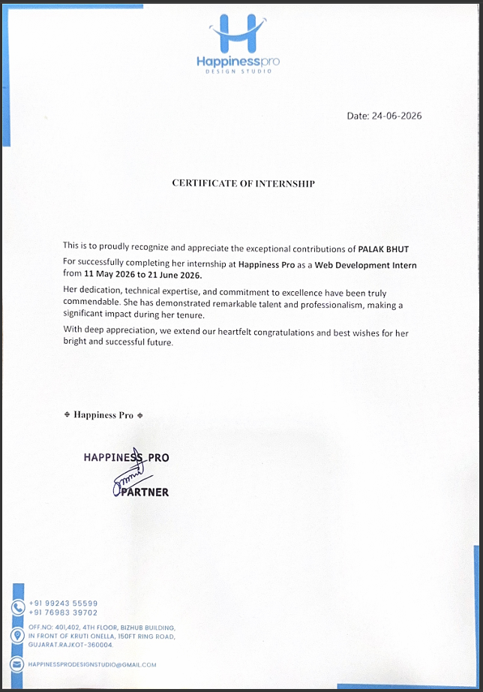

Acknowledgement

I take this opportunity to express my sincere gratitude to everyone who supported and guided me throughout the successful completion of my Summer Internship Project.
First and foremost, I would like to express my heartfelt gratitude to my faculty guide, Prof. Parmanand Patel, U & P U. Patel Department of Computer Engineering, CSPIT/FTE, CHARUSAT, for providing continuous guidance, valuable suggestions, encouragement, and motivation throughout the internship. Their support and constructive feedback played a vital role in the successful completion of this project.
I would also like to express my sincere thanks to Dr. A. D. Patel (Principal), Dr. Amit Ganatra (Dean), Dr. Nikita Bhatt(Head of Department) for providing me with the opportunity to undertake the Summer Internship as a part of the curriculum and for creating an excellent academic environment that encouraged practical learning.
I am highly thankful to my industry mentor and the entire team at my internship company for providing me with the opportunity to work on the project "AI Powered Custom Trip Planner Using WordPress and Google Gemini AI." Their guidance, technical support, and practical insights helped me gain valuable industry experience and improve my technical skills.
Finally, I would like to express my heartfelt gratitude to my parents, family members, and friends for their constant encouragement, patience, and moral support throughout the internship period. Their motivation inspired me to complete this project successfully.
I sincerely thank everyone who directly or indirectly contributed to the successful completion of this internship project.

Abstract

The proposed project is an AI Powered Custom Trip Planner that provides users with a smart and convenient platform to plan their trips efficiently. It is a WordPress-based web application integrated with Google Gemini AI, designed to simplify travel planning by generating personalized travel itineraries based on user preferences.
The system allows users to enter travel details such as destination, budget, travel dates, number of travelers, travel style, and interests. Based on these inputs, the AI generates a detailed travel plan including a trip overview, day-wise itinerary, hotel recommendations, transportation suggestions, estimated budget breakdown, popular tourist attractions, food recommendations, and travel tips.
The website also includes a Trip Budget Calculator, which enables users to estimate their travel expenses by entering costs for accommodation, food, transportation, and activities. In addition, users can explore various travel destinations, read informative travel blogs, learn about the services offered, and contact the travel planner through an integrated contact form.
The proposed system provides an intuitive, responsive, and user-friendly interface that reduces the time and effort required for travel planning. By combining Artificial Intelligence with modern web technologies, the platform delivers a personalized and professional travel planning experience while demonstrating the practical application of AI in the tourism industry.

Table of Contents

Acknowledgement i
Abstract ii
CHAPTER-1 INTRODUCTION 1
  - PURPOSE OF INTERNSHIP 1
  - OVERVIEW OF PROJECT 1
  - OBJECTIVE 4
  - SCOPE 4
CHAPTER-2 SYSTEM ANALYSIS 5
  - REQUIREMENTS OF NEW SYSTEM 5
    - FUNCTIONAL REQUIREMENTS 5
    - NON-FUNCTIONAL REQUIREMENTS 8
  - HARDWARE REQUIREMENTS 10
  - SOFTWARE REQUIREMENTS 10
CHAPTER-3 SYSTEM DESIGN 11
  - DATA DICTIONARY 11
  - ER DIAGRAM 14
CHAPTER-4 IMPLEMENTATION SCREENSHOTS 15
  - HOME PAGE 15
  - ABOUT PAGE 16
  - OFFERINGS PAGE 17
  - BLOG PAGE 17
  - CONTACT PAGE 18
  - DESTINATION EXPLORER 18
  - AI CHATBOT 19
  - BUDGET PLANNER 19
CHAPTER-5 TEST CASES 20
  - TESTING STRATEGY 20
CHAPTER-6 LIMITATIONS AND FUTURE ENHANCEMENTS 23
  - LIMITATIONS 23
  - FUTURE ENHANCEMENTS 23
CHAPTER-7 CONCLUSION 24
Biblography vi
Fig 3.2.1 ER Diagram 14
Fig 4.1.1 Home Screen 15
Fig 4.1.2 Service section 15
Fig 4.2.1 About Page 16
Fig 4.2.2 FAQ section 16
Fig 4.3.1 Offerings Page 17
Fig 4.4.1Blog page 17
Fig 4.5.1Contact page 18
Fig 4.6.1Destination Explorer 18
Fig 4.7.1AI chatbot 19
Fig 4.8.1Budget calculator 19

List of Tables

Table 3.1 Data Dictionary 11
Table 5.1 Ai trip planner test case ……………………………………………………...…………………20
Table 5.2 Budget calculator test case 21
Table 5.3 Contact Form test case 22

CHAPTER-1 INTRODUCTION

PURPOSE OF INTERNSHIP
The primary purpose of this internship was to gain practical knowledge and hands-on experience in web development using WordPress and to understand the integration of Artificial Intelligence into real-world applications. The internship provided an opportunity to apply theoretical concepts learned during the academic program to develop a professional web-based project in an industrial environment.
During the internship, I designed and developed an AI Powered Custom Trip Planner using WordPress, Google Gemini AI, and various WordPress plugins. This experience enhanced my technical skills, improved my problem-solving abilities, and helped me understand the complete software development process, from requirement analysis and website design to implementation, testing, and documentation.
The objectives of this internship are:
- To gain practical experience in WordPress website development.
- To learn AI integration using Google Gemini API.
- To understand the use of WordPress themes, plugins, and content management systems.
- To develop a real-world AI-based travel planning application.
- To improve problem-solving, debugging, and testing skills.
- To enhance knowledge of responsive web design and user interface development.
- To understand the software development life cycle (SDLC) in an industrial environment.
- To develop professional communication, documentation, and project management skills.
- To work independently while following industry standards and best practices.
- To bridge the gap between academic learning and practical industry experience.

OVERVIEW OF PROJECT
The AI Powered Custom Trip Planner is a web-based application developed using WordPress and integrated with Google Gemini AI to simplify travel planning. The website provides users with an intelligent platform for generating personalized travel itineraries, estimating trip budgets, and exploring travel destinations. The system consists of the following modules:
1. Home Module
- Displays an attractive homepage with a professional travel-themed design.
- Introduces the Custom Trip Planner website and its key features.
- Provides easy navigation to all pages of the website.
- Highlights featured destinations and encourages users to start planning their trips.
2. Destination Explorer Module
- Allows users to explore various travel destinations.
- Displays destination images, descriptions, tourist attractions, and travel information.
- Provides information about the best time to visit each destination.
- Helps users choose destinations according to their interests.
3. AI Trip Planner Module
- Allows users to generate personalized travel plans using Google Gemini AI.
- Collects user information such as:
  - Destination
  - Budget
  - Travel Dates
  - Number of Travelers
  - Travel Style (Solo, Couple, Family, Friends)
  - Interests
- Generates:
  - Trip Overview
  - Day-wise Itinerary
  - Hotel Recommendations
  - Transportation Suggestions
  - Estimated Budget Breakdown
  - Tourist Attractions
  - Food Recommendations
  - Travel Tips
4. Trip Budget Calculator Module
- Helps users estimate their overall travel expenses.
- Users enter:
  - Hotel Cost
  - Food Cost
  - Transportation Cost
  - Activities Cost
- Automatically calculates the total estimated trip cost.
- Assists users in planning trips within their budget.
5. Offerings Module
- Displays the travel-related services offered by the website.
- Includes customized travel planning services.
- Provides itinerary planning assistance.
- Offers destination recommendations and travel consultation.
- Helps users understand the available travel solutions.
6. Travel Blog Module
- Displays travel blogs and informative articles.
- Shares travel tips and destination guides.
- Provides recommendations for tourists.
- Keeps users informed about popular travel destinations and experiences.
7. Contact Module
- Provides a contact form for users to send inquiries.
- Allows users to communicate with the travel planner.
- Collects visitor details such as name, email, subject, and message.
- Improves communication between users and the website administrator.
8. Admin Module
- Allows the administrator to manage the website through the WordPress Dashboard.
- Create, edit, and delete website pages.
- Manage travel destinations, blogs, and offerings.
- Configure AI chatbot settings.
- Manage website content, plugins, and themes.
- Update website information whenever required.
- Monitor and maintain the overall functionality of the website.

OBJECTIVE
To automate the travel planning process by generating personalized AI-based travel itineraries according to the user's preferences and to provide an easy-to-use platform for trip planning, destination exploration, and budget estimation.

SCOPE
The scope of the AI Powered Custom Trip Planner is to provide users with an intelligent web-based platform for planning their trips efficiently. The website can be used by individual travelers, families, couples, and groups to generate personalized travel itineraries based on their preferences.The system enables users to explore travel destinations, estimate travel expenses using a budget calculator, generate AI-powered travel plans, read travel blogs, and contact the travel planner through an integrated contact form. By integrating Google Gemini AI with WordPress, the project demonstrates how Artificial Intelligence can simplify travel planning and enhance the overall user experience. Although the current system focuses on itinerary generation and budget estimation, it can be extended in the future with features such as hotel booking, flight reservation, online payments, weather forecasting, and Google Maps integration.

CHAPTER-2 SYSTEM ANALYSIS

REQUIREMENTS OF NEW SYSTEM

FUNCTIONAL REQUIREMENTS

Home Module
- Homepage
  - Input: User visits the website.
  - Output: Displays homepage with navigation menu, featured destinations, and project information.
  - Processing: Loads website content and provides navigation to different modules.

Destination Explorer Module
- View Destinations
  - Input: User selects a destination.
  - Output: Displays destination details, images, tourist attractions, and travel information.
  - Processing: Retrieves destination content stored in WordPress.

AI Trip Planner Module
- Generate AI Travel Plan
  - Input:
    - Destination
    - Budget
    - Travel Dates
    - Number of Travelers
    - Travel Style
    - Interests
  - Output:
    - Trip Overview
    - Day-wise Itinerary
    - Hotel Recommendations
    - Transportation Suggestions
    - Budget Breakdown
    - Tourist Attractions
    - Food Recommendations
    - Travel Tips
  - Processing: User inputs are sent to Google Gemini AI through the AI Engine plugin, which generates a personalized travel itinerary.

Budget Calculator Module
- Estimate Trip Cost
  - Input:
    - Hotel Cost
    - Food Cost
    - Transportation Cost
    - Activities Cost
  - Output: Displays the total estimated trip cost.
  - Processing: Calculates the sum of all entered expenses using the Calculated Fields Form plugin.

Offerings Module
- View Services
  - Input: User opens the Offerings page.
  - Output: Displays available travel planning services.
  - Processing: Retrieves service information from WordPress pages.

Travel Blog Module
- Read Blogs
  - Input: User selects a blog article.
  - Output: Displays travel-related articles and guides.
  - Processing: Retrieves blog content from the WordPress database.

Contact Module
- Send Inquiry
  - Input:
    - Name
    - Email
    - Subject
    - Message
  - Output: Confirmation that the inquiry has been submitted.
  - Processing: Stores or sends the inquiry through the contact form plugin.

Website Navigation Module
- Browse Website
  - Input: User clicks menu items.
  - Output: Opens the selected webpage.
  - Processing: Routes the user to the requested page within the website.

Administrator Module
Manage Website Content
- Input: Login credentials.
- Output: Access to WordPress Dashboard.
- Processing: Authenticates administrator.
Manage Pages
- Input: Add/Edit/Delete page content.
- Output: Updated website pages.
- Processing: Saves changes in the WordPress database.
Manage AI Chatbot
- Input: Update AI prompt or chatbot settings.
- Output: Improved AI responses.
- Processing: Updates AI Engine configuration.
Manage Blog Posts
- Input: Create/Edit/Delete blog posts.
- Output: Updated blog section.
- Processing: Stores blog content in WordPress.
Manage Destinations
- Input: Add/Edit/Delete destination information.
- Output: Updated destination pages.
- Processing: Updates destination content.
Manage Offerings
- Input: Add/Edit/Delete services.
- Output: Updated Offerings page.
- Processing: Saves service information.
Manage Contact Information
- Input: Update email, phone number, and contact details.
- Output: Updated Contact page.
- Processing: Saves website contact information.

NON-FUNCTIONAL REQUIREMENTS

• Usability
- The website provides a simple, clean, and user-friendly interface that allows users to easily plan their trips.
- Navigation is intuitive, enabling users to access features such as the AI Trip Planner, Budget Calculator, Destination Explorer, Blog, and Contact page without any technical knowledge.

• Efficiency of Use
- Users can quickly generate personalized travel itineraries by entering a few travel details.
- The AI-powered planner reduces the time and effort required for travel planning.
- The Budget Calculator instantly calculates the estimated trip cost based on user inputs.
- The website is responsive and works efficiently on desktops, tablets, and mobile devices.

• Reliability
- The website should provide accurate and consistent responses while generating travel itineraries.
- The AI chatbot should process user requests reliably whenever an internet connection is available.
- All website pages and modules should function without errors or unexpected failures.
- The Budget Calculator should always produce accurate calculations based on the entered values.

• Performance
- The homepage and other website pages should load within 3–5 seconds under normal internet conditions.
- AI-generated travel itineraries should be displayed within a few seconds after the user submits the required travel details.
- The website should support multiple users accessing the system simultaneously without affecting performance.
- Navigation between pages should be smooth and responsive.

• Security
- Administrative access to the WordPress dashboard is protected using secure login credentials.
- Only authorized administrators can edit website content, AI settings, blogs, and travel destinations.
- User inputs are validated before processing to minimize invalid or malicious data.
- Sensitive API credentials, such as the Google Gemini API key, are securely stored and not exposed to website visitors.
- The website follows WordPress security best practices by using trusted themes, plugins, and regular updates.

• Maintainability
- The website is built using WordPress, making it easy to maintain and update.
- New destinations, blogs, services, and website content can be added without modifying the source code.
- Plugins and themes can be updated independently to improve functionality and security.

• Scalability

- The website can be expanded in the future by integrating additional features such as hotel booking, flight booking, weather forecasting, Google Maps, payment gateways, and user authentication.
- The modular architecture allows new pages and functionalities to be added with minimal changes to the existing system.

HARDWARE REQUIREMENTS
Processor: Intel Core i3 / AMD Ryzen 3 or higher
Processor Speed: 2.0 GHz or above
RAM: Minimum 4 GB (8 GB Recommended)
Hard Disk: Minimum 20 GB Free Space
Display Resolution: 1366 × 768 or higher
Internet Connection: Required for Google Gemini AI integration and plugin updates

SOFTWARE REQUIREMENTS

Windows 10 / Windows 11 -operating system
XAMPP -local server
WordPress -content management system
MySQL -database
Astra -theme
AI Engine (Meow Apps) -plugins
Spectra
SureForms
Calculated Fields Form
SureRank SEO
LatePoint
Google Gemini AI API -ai service
Google Chrome -web browser

CHAPTER-3 SYSTEM DESIGN

DATA DICTIONARY

Table 3.1 Data dictionary

Table Name | Field Name | Data Type
Customers (wp_latepoint_customers) | id | PK
 | uuid | String
 | first_name | String
 | last_name | String
 | email | String
 | phone | String
 | password | String
 | status | String
 | created_at | DateTime
 | updated_at | DateTime
Service Categories (wp_latepoint_service_categories) | id | PK
 | name | String
 | short_description | String
 | parent_id | FK
 | created_at | DateTime
 | updated_at | DateTime
Services (wp_latepoint_services) | id | PK
 | category_id | FK
 | name | String
 | short_description | String
 | charge_amount | Decimal
 | duration | Integer
 | capacity_min | Integer
 | capacity_max | Integer
 | status | String
 | visibility | String
 | created_at | DateTime
 | updated_at | DateTime
Locations (wp_latepoint_locations) | id | PK
 | category_id | FK
 | name | String
 | full_address | String
 | status | String
 | created_at | DateTime
 | updated_at | DateTime
Bookings (wp_latepoint_bookings) | id | PK
 | booking_code | String
 | customer_id | FK
 | service_id | FK
 | agent_id | FK
 | location_id | FK
 | start_date | Date
 | end_date | Date
 | start_time | Integer
 | end_time | Integer
 | status | String
 | total_attendees | Integer
 | created_at | DateTime
 | updated_at | DateTime
Orders (wp_latepoint_orders) | id | PK
 | customer_id | FK
 | subtotal | Decimal
 | total | Decimal
 | payment_status | String
 | fulfillment_status | String
 | status | String
 | coupon_code | String
 | tax_total | Decimal
 | created_at | DateTime
 | updated_at | DateTime
Transactions (wp_latepoint_transactions) | id | PK
 | invoice_id | FK
 | order_id | FK
 | customer_id | FK
 | processor | String
 | payment_method | String
 | kind | String
 | status | String
 | amount | Decimal
 | receipt_number | String
 | created_at | DateTime
 | updated_at | DateTime

3.2 ER DIAGRAM
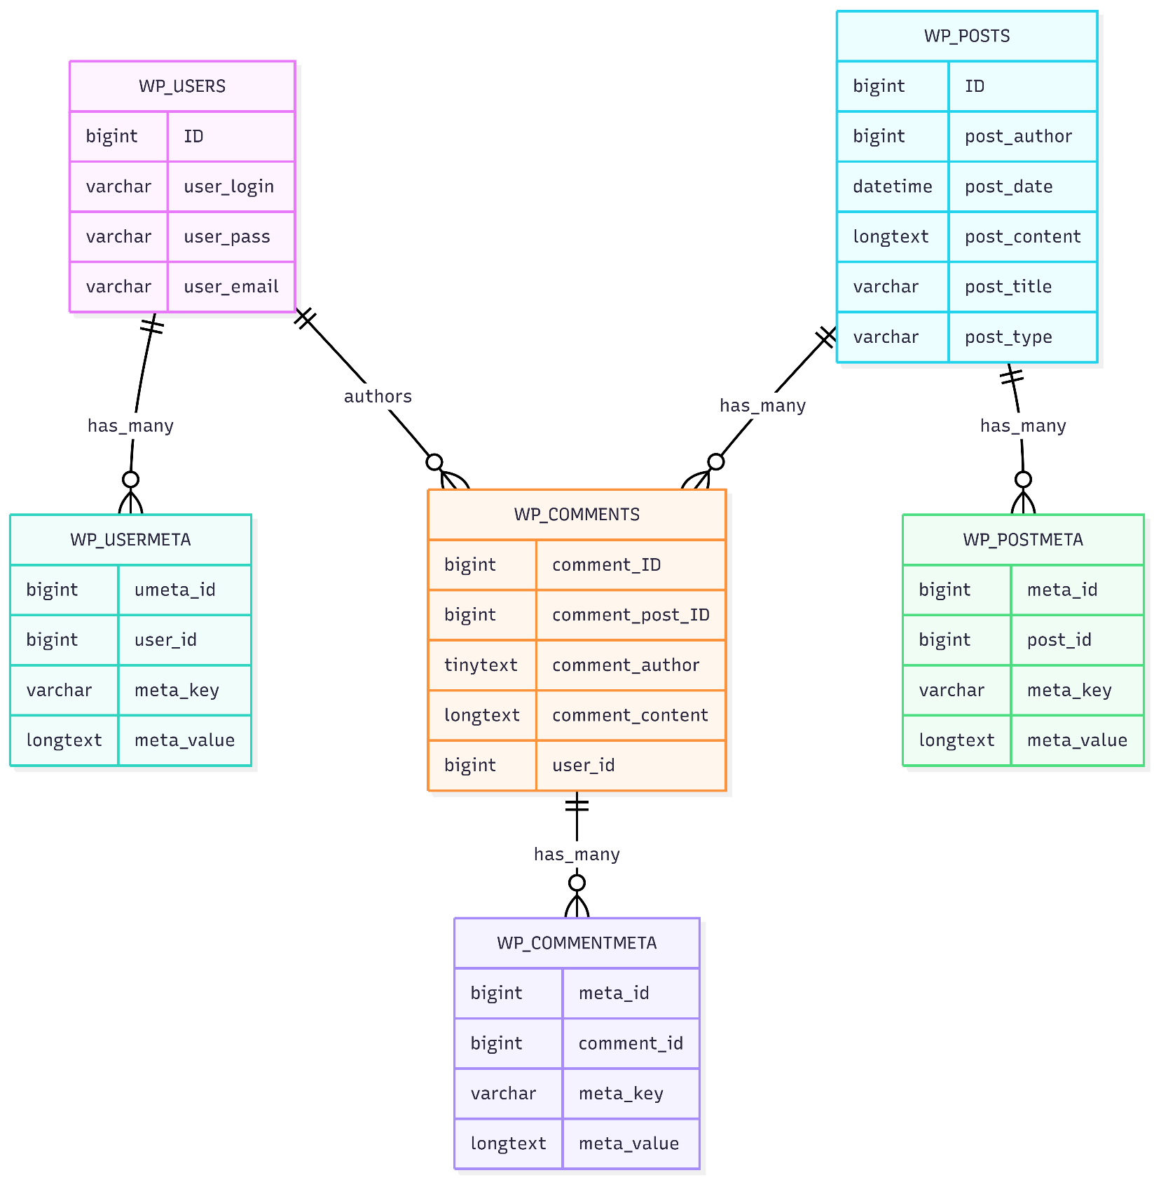
Fig 3.2.1 ER Diagram

CHAPTER-4 IMPLEMENTATION SCREENSHOTS

HOME PAGE



Fig 4.1.1 Home Screen
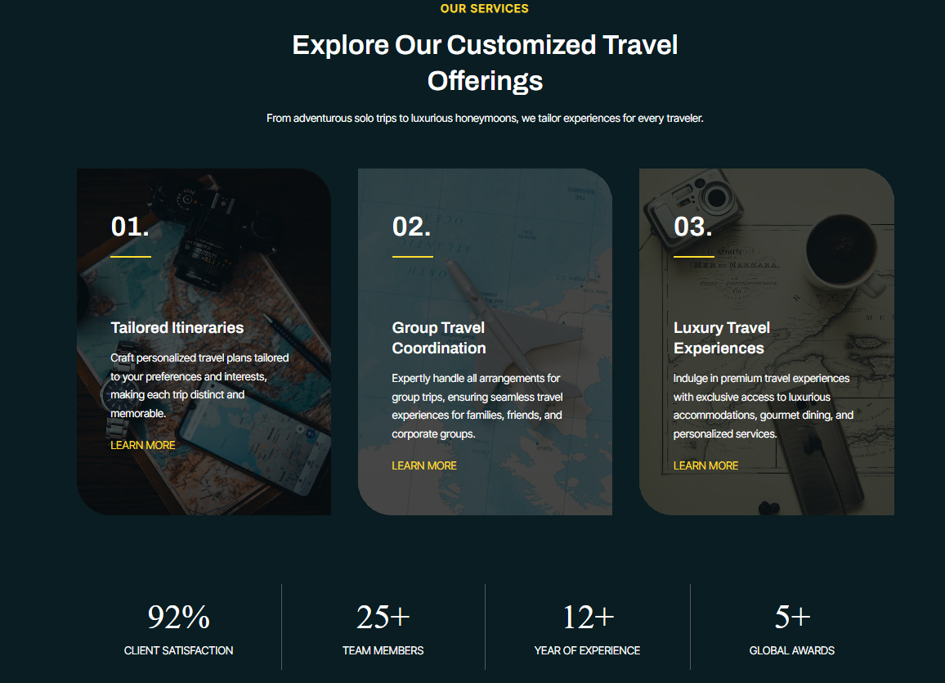

Fig 4.1.2 services section

4.2 ABOUT PAGE



Fig 4.2.1 About Page

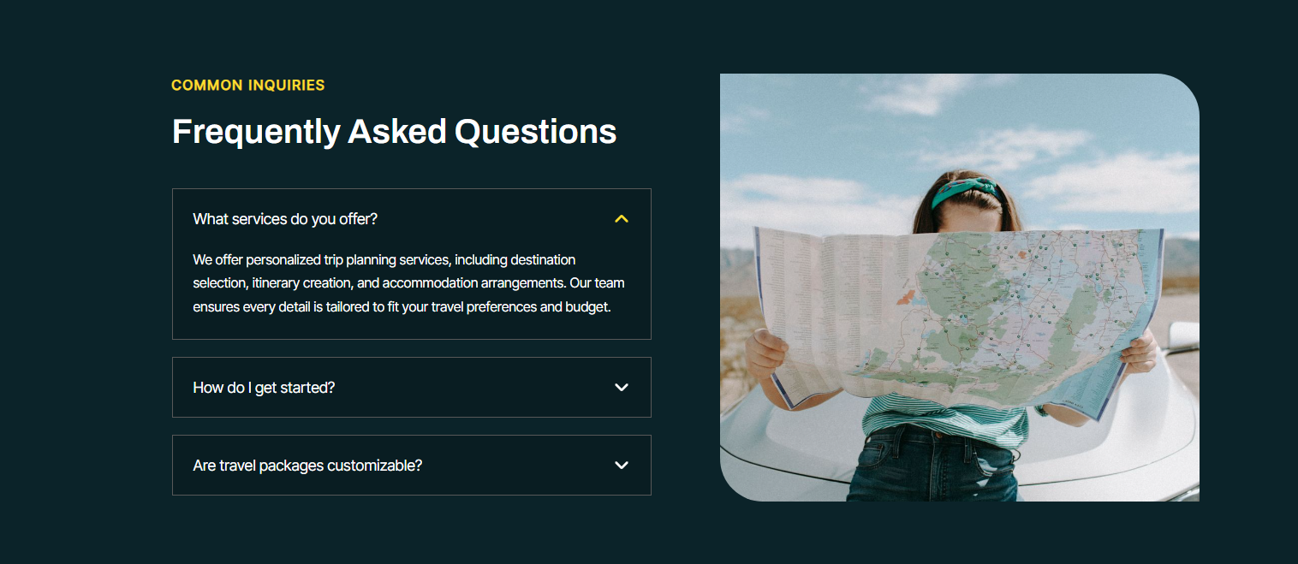Fig 4.2.2 FAQ section

OFFERINGS PAGE



Fig 4.3.1 Offerings Page

4.4 BLOG PAGE


Fig 4.4.1 Blog Page

CONTACT PAGE
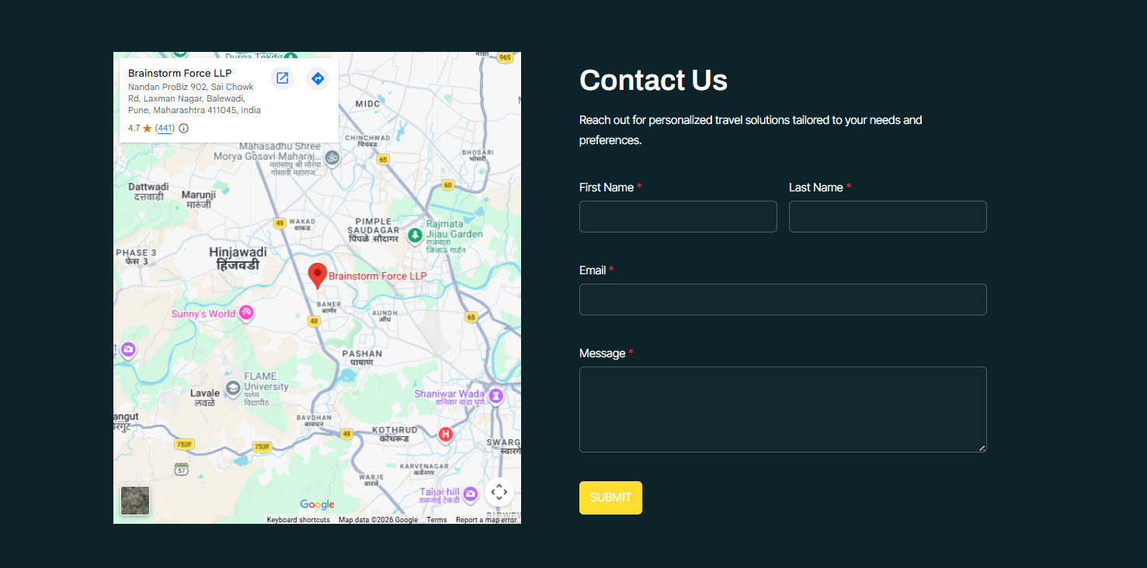
Fig 4.5.1 Contact Page

4.6 DESTINATION EXPLORER



Fig 4.6.1 Destination explorer

AI CHATBOT

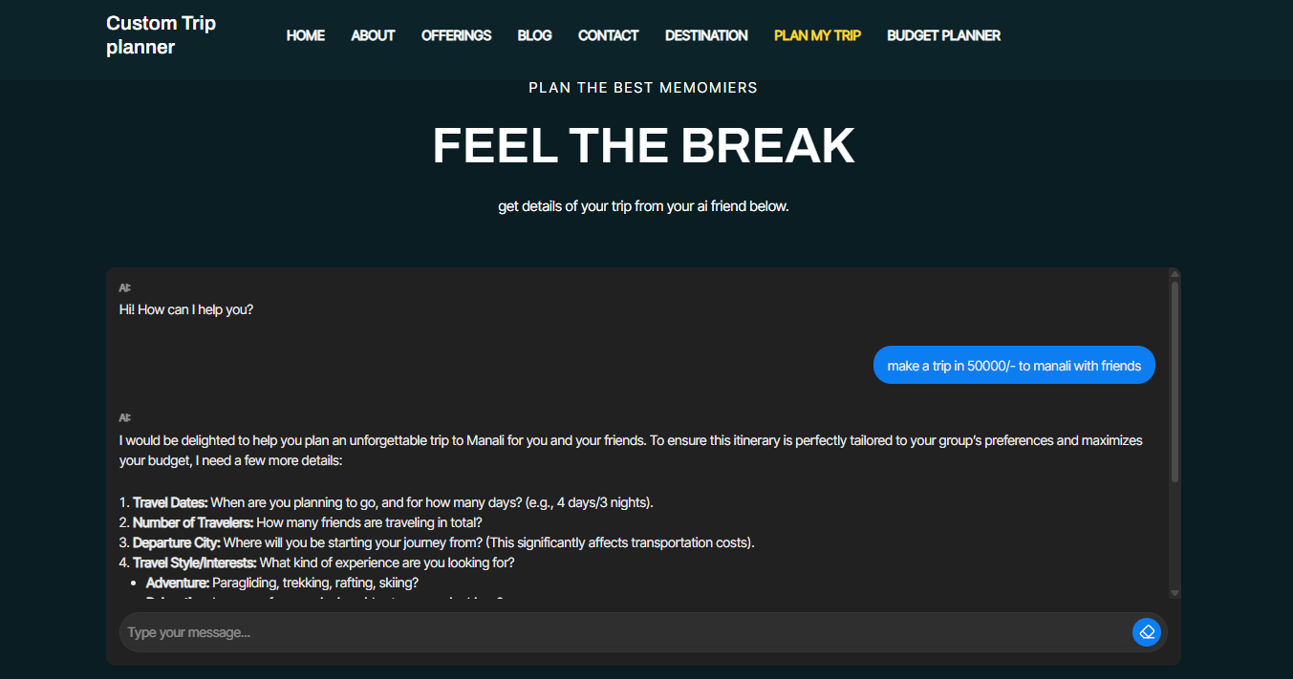
Fig 4.7.1 Ai chatbot

4.8 BUDGET PLANNER
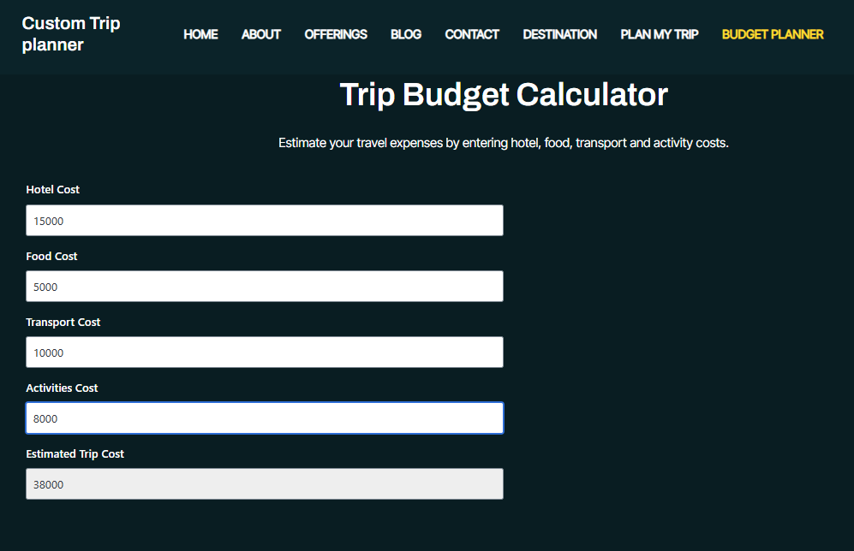

Fig 4.8.1 Budget calculator

CHAPTER-5 TEST CASES

TESTING STRATEGY
The project was tested using Unit Testing and Functional Testing. Each module of the website was tested individually to verify that it performs the intended functionality. Both valid and invalid inputs were tested to ensure reliability and correctness.
Module Name – AI Trip Planner
Table 5.1 AI Trip planner test case

Test Case No. | Test Scenario | Pre-condition | Test Steps | Test Data | Expected Result | Actual Result | Status
1 | Generate travel itinerary | User opens Plan My Trip page | Enter destination, budget, dates, travellers, travel style and interests | Valid data | AI generates complete personalized itinerary | Same as expected | PASS
2 | Missing required information | User opens Plan My Trip page | Leave destination empty | Invalid data | AI asks user to provide missing information | Same as expected | PASS
3 | Invalid budget | User enters negative budget | Submit request | Invalid budget | AI requests valid budget | Same as expected | PASS

Module Name – Budget Calculator

Table 5.2 Budget Calculator Test Case

Test Case No. | Test Scenario | Pre-condition | Test Steps | Test Data | Expected Result | Actual Result | Status
1 | Calculate trip cost | Budget Calculator page opened | Enter Hotel, Food, Transport and Activities cost | Valid numeric values | Total Estimated Trip Cost calculated correctly | Same as expected | PASS
2 | Empty input | Calculator page opened | Leave one field empty | Partial data | Missing field treated as 0 / prompt user | Same as expected | PASS
3 | Invalid characters | Calculator page opened | Enter alphabets | Invalid input | Validation message displayed | Same as expected | PASS

Module Name : Contact Form

Table 5.3 Contact Form test case

Test Case No. | Test Scenario | Pre-condition | Test Steps | Test Data | Expected Result | Actual Result | Status
1 | Submit contact form | Contact page opened | Fill all required details | Valid data | Form submitted successfully | Same as expected | PASS
2 | Missing email | Contact page opened | Leave email blank | Invalid data | Error message displayed | Same as expected | PASS
3 | Invalid email | Contact page opened | Enter invalid email | Invalid email | Validation error displayed | Same as expected | PASS

ENHANCEMENTS

CHAPTER-6 LIMITATIONS AND FUTURE ENHANCEMENTS

LIMITATIONS

- The AI-generated travel itinerary is based on the information provided by the user. If incomplete or incorrect details are entered, the recommendations may not fully match the user's expectations.
- The website currently provides travel planning and budget estimation only. It does not support real-time hotel booking, flight booking, or online payment services.
- The AI Trip Planner requires an active internet connection to communicate with the Google Gemini AI API. Without internet connectivity, AI-generated itineraries cannot be produced.
- Destination information and travel blogs require periodic updates by the administrator to keep the content accurate and relevant.
- The Budget Calculator provides estimated expenses only. Actual travel costs may vary depending on season, destination, accommodation, transportation, and personal preferences.
- The current system is designed as a travel planning platform and can be extended in the future with features such as user accounts, booking integration, weather forecasts, and live travel information.

FUTURE ENHANCEMENTS

Since this project is the initial version of the AI Powered Custom Trip Planner, there are several features that can be implemented in future versions to improve its functionality and provide a more complete travel planning experience.

- Online Hotel Booking: Allow users to book hotels directly through the website using travel booking APIs.
- Flight and Train Booking: Integrate flight and railway booking services so users can complete their entire trip planning from a single platform.
- Real-Time Weather Forecast: Display current weather conditions and forecasts for selected destinations to help users plan their trips more effectively.
- Interactive Maps: Integrate Google Maps to provide navigation, nearby attractions, hotels, restaurants, and route planning.
- User Login and Saved Trips: Allow users to create accounts, save their travel itineraries, and access previous trip plans anytime.
- Online Payment Integration: Enable secure online payments for travel packages, bookings, and premium planning services.
- Multilingual Support: Support multiple languages so that users from different regions can use the website comfortably.
- Live Travel Updates: Provide users with real-time information about flight schedules, traffic conditions, travel advisories, and local events.
- Personalized AI Recommendations: Improve the AI system to remember user preferences and suggest destinations, hotels, and activities based on previous trips.
- Mobile Application: Develop Android and iOS applications so users can access the AI Trip Planner conveniently from their smartphones.

CHAPTER-7 CONCLUSION

The AI Powered Custom Trip Planner is a smart web-based travel planning system developed using WordPress and Google Gemini AI. The website simplifies the travel planning process by allowing users to generate personalized travel itineraries based on their destination, budget, travel dates, number of travelers, travel style, and interests.
The system includes an AI Trip Planner, Trip Budget Calculator, Destination Explorer, Travel Services, Blog, and Contact module, providing users with a complete travel planning experience through a modern and user-friendly interface. The integration of Google Gemini AI enables users to receive intelligent, customized travel recommendations within seconds, making trip planning faster and more convenient.
The website also demonstrates how Artificial Intelligence can be effectively integrated into a WordPress platform to improve user experience without requiring extensive custom coding. Overall, this project provides an efficient, interactive, and scalable solution for travelers and serves as a strong foundation for future enhancements such as online hotel booking, flight booking, weather updates, payment integration, and user account management.

BIBLIOGRAPHY

    - https://wordpress.org/
    - https://developer.wordpress.org/
    - https://wordpress.org/plugins/ai-engine/
    - https://ai.thehiddendocs.com/ (AI Engine Plugin Documentation)
    - https://ai.google.dev/ (Google Gemini AI Documentation)
    - https://wordpress.org/themes/astra/
    - https://wpspectra.com/docs/
    - https://wordpress.org/plugins/sureforms/
    - https://wordpress.org/plugins/calculated-fields-form/
    - https://wordpress.org/plugins/surerank/
    - https://www.apachefriends.org/ (XAMPP)
    - https://www.mysql.com/
    - https://developer.mozilla.org/ (HTML, CSS & JavaScript Reference)

